**Assignment 1 🡪 Pipeline 1 -Job**

**Slave1-httpd-index-deploy**

**Slave2-httpd-index-deploy**

**Slave3-httpd-index-deploy**

**Jenkins-master**

**22Q1-clone**

**22Q2-clone**

**22Q3-clone**

**Git Repo**

**Step 1:** Launch & connect 3 slaves instances 🡪 slave1, slave2, slave3

yum install httpd –y 🡪 service httpd start

chmod –R 777 /var/www/html

yum install java-1.8.0-openjdk-devel.x86_64 –y

**step 2: Create Nodes/agent**

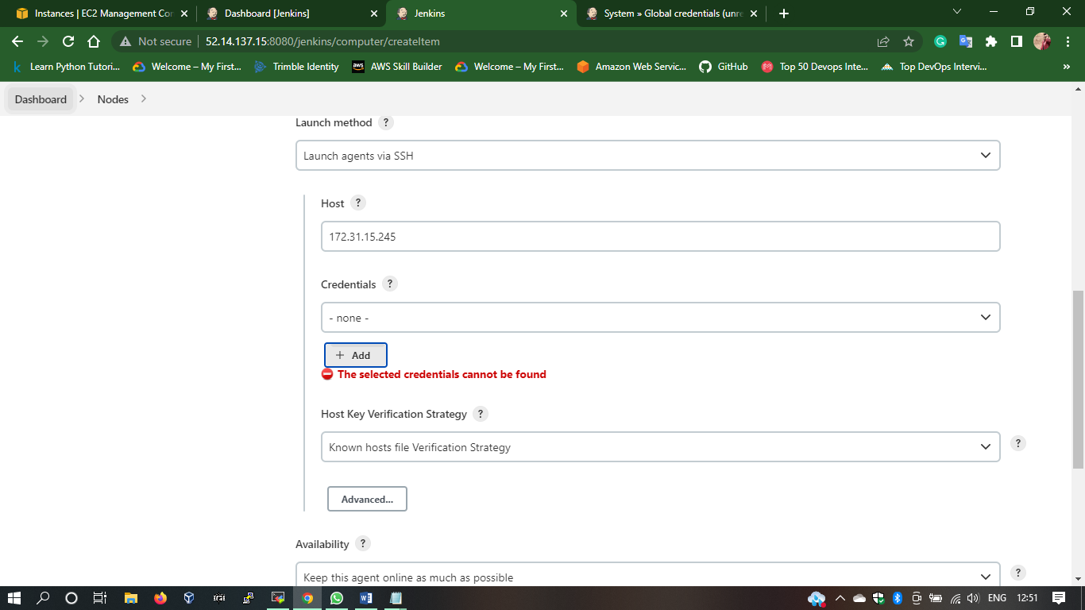

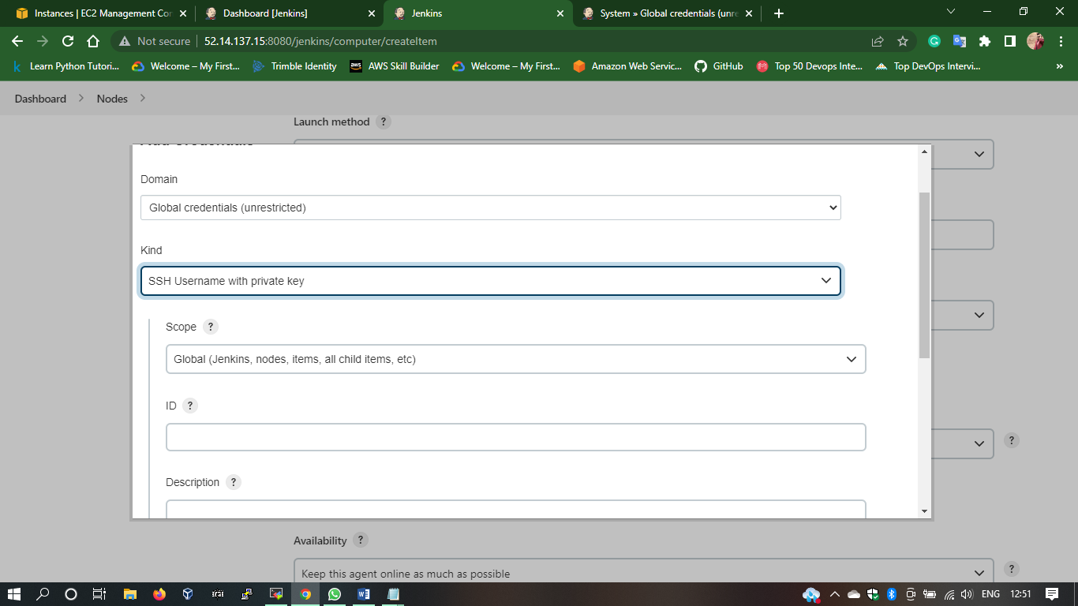

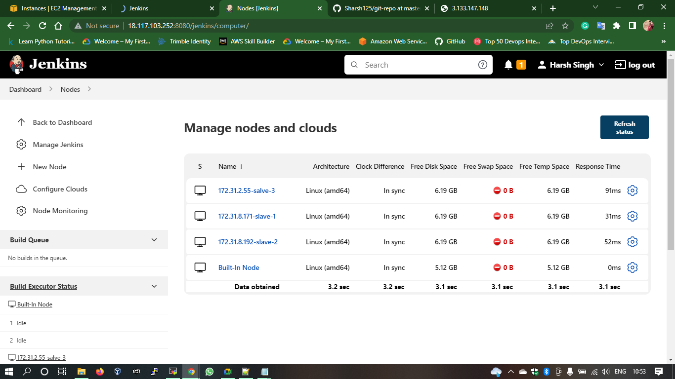

**Step 3: Create 1 pipeline jobs**

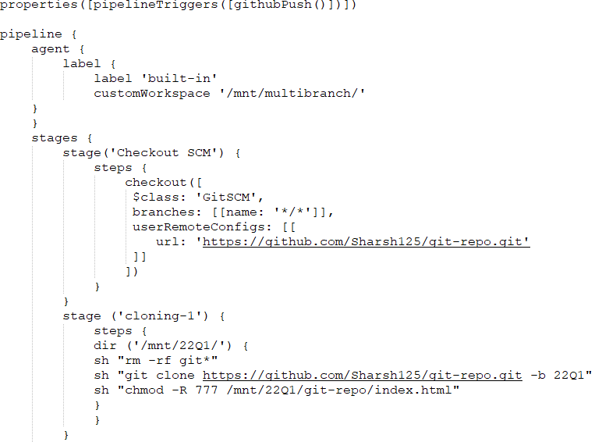

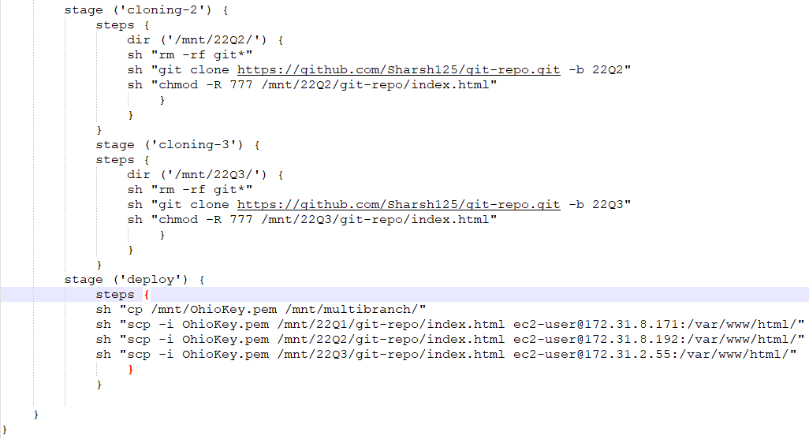

**Step 3: Build & Result**

